horizontal line

**STL Digital**

8th floor, the cube 100ft

Near Nagavara lake,

Bengaluru, Karnataka 560045

Telecom Web Application

**Submitted by**- Anirban Paul

**Employee Id**- 24908733

**Acknowledgement**

I would like to express my special thanks of gratitude to our project mentor Piyush Singh and Supriya Ankolekar for their able guidance and support.

**CONTENTS**

| **S.No** | **Topics** | **Page no** |
| --- | --- | --- |
| 1. | Acknowledgement | 2 |
| 2. | Aim of the project | 4 |
| 3. | Technology Requirements | 5 |
| 4. | Flowchart of Project | 6 |
| 5. | Backend | 7 |
| 6. | DB Schema/Diagram | 7 |
| 7. | Frontend of Telecom Web Application | 8 |
| 8. | Component Details | 9-14 |
| 9. | Conclusion | 15 |

**Aim of the Project**

The aim of the project is to build a Telecom Web Application using Spring Boot, MySQL as backend and Angular as frontend. Also, it should have JWT authentication while logging in and performing tasks.

**Technology Requirements**

1. Front-End →

a) HTML

b) CSS

c) TypeScript

d) Routing

1. Back-End →

a) Spring Boot

b) JWT Authentication

c) MySQL

d) Microservices

e) Postman

**Flowchart of project**

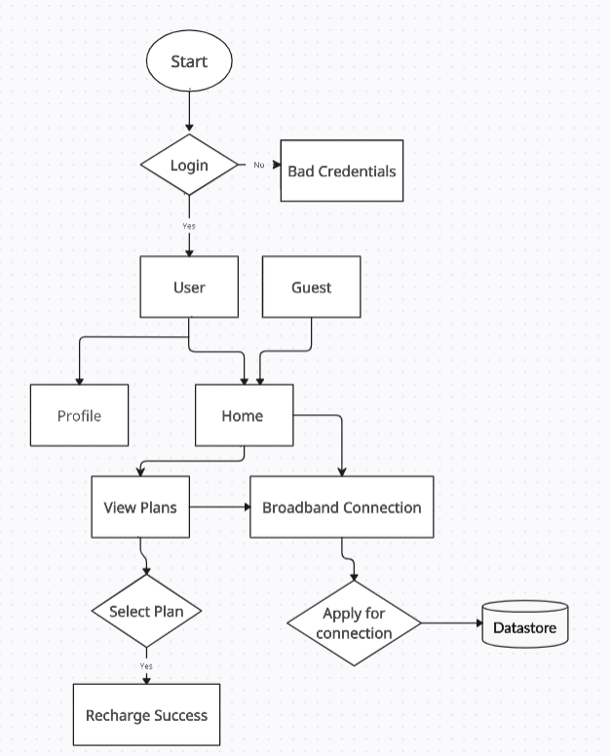

**Backend**

The whole backend is built on microservices architecture. In this application, there are 6 microservices. I am using MySQL database to store user details which consists of one database and five tables.

**DB Schema/Diagram**

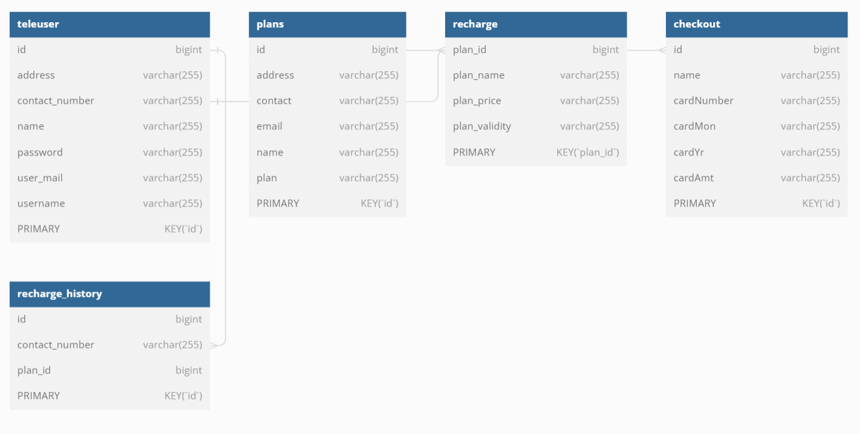

**Front-End of Telecom Web Application**

In this project, I am using Angular framework for developing frontend application where I have divided the whole view in the form of components and configured it.

Here, I have displayed my homepage view —>

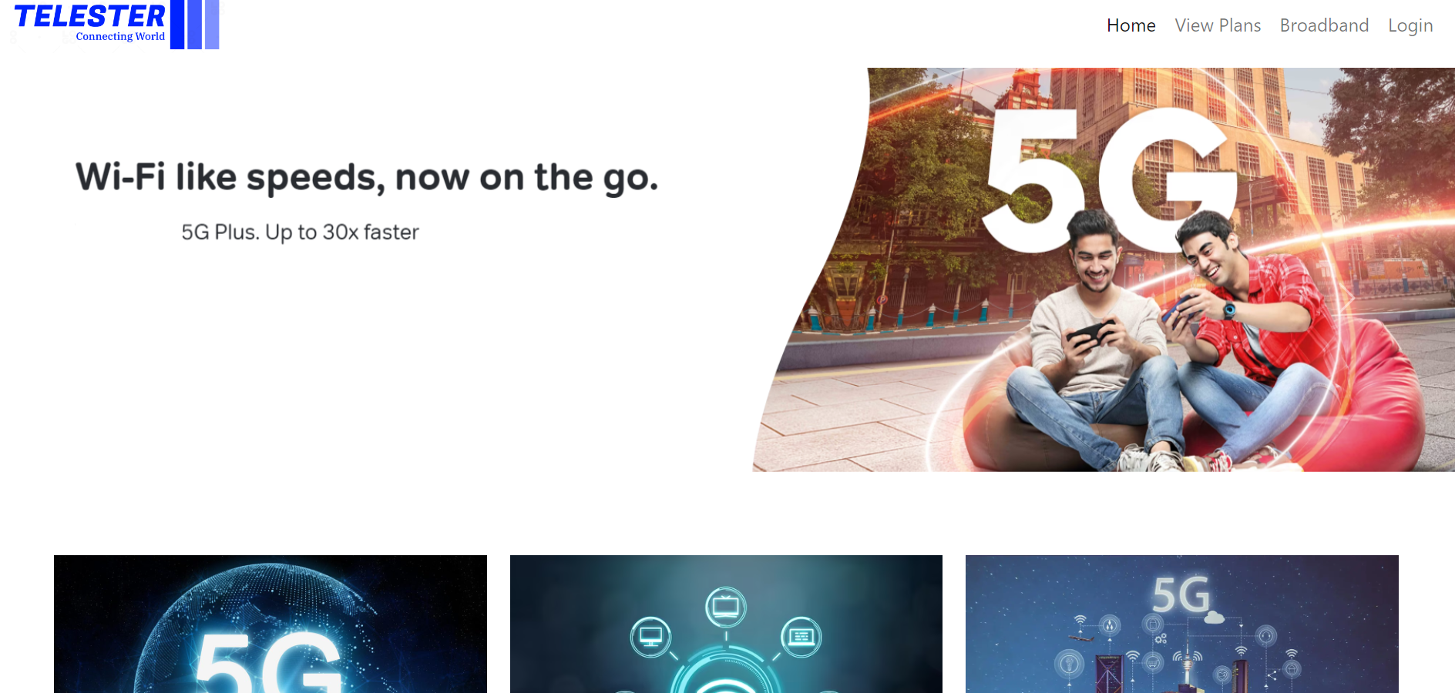

The components I used:

1. Navbar
2. View Plans
3. Broadband
4. Register/Signup
5. Login
6. Profile
7. Checkout
8. Transaction

**Components Details**

1. **Navbar Component**

This component contains all the header view like brand logo, home, view plans, broadband, login, profile navigating links.

When user clicks any of the links present in navbar, it will call the respective service and fulfill the user request.

**Fig. Navbar component**



1. **View Plans Component**

When user clicks on view plans link, it will open a page where it will show types of plans available to recharge and the plan details.

After the user clicks on the select plan button, it will navigate the user to the transaction page, where user have to fill in necessary details to fulfill the transaction.

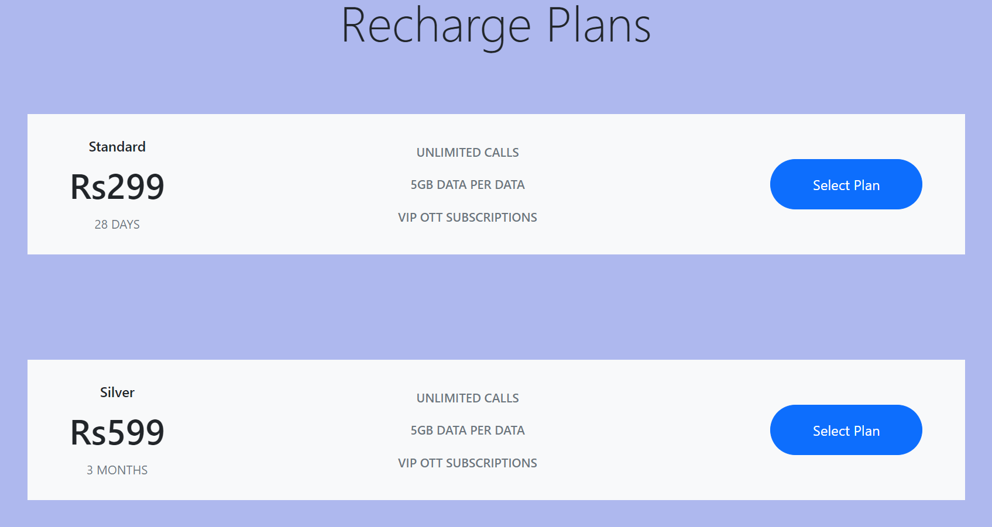

1. **Broadband Component**

When user/guest clicks on the broadband connection link, it will redirect to the broadband connection register page, where user have to fill necessary details to apply for new broadband connection.

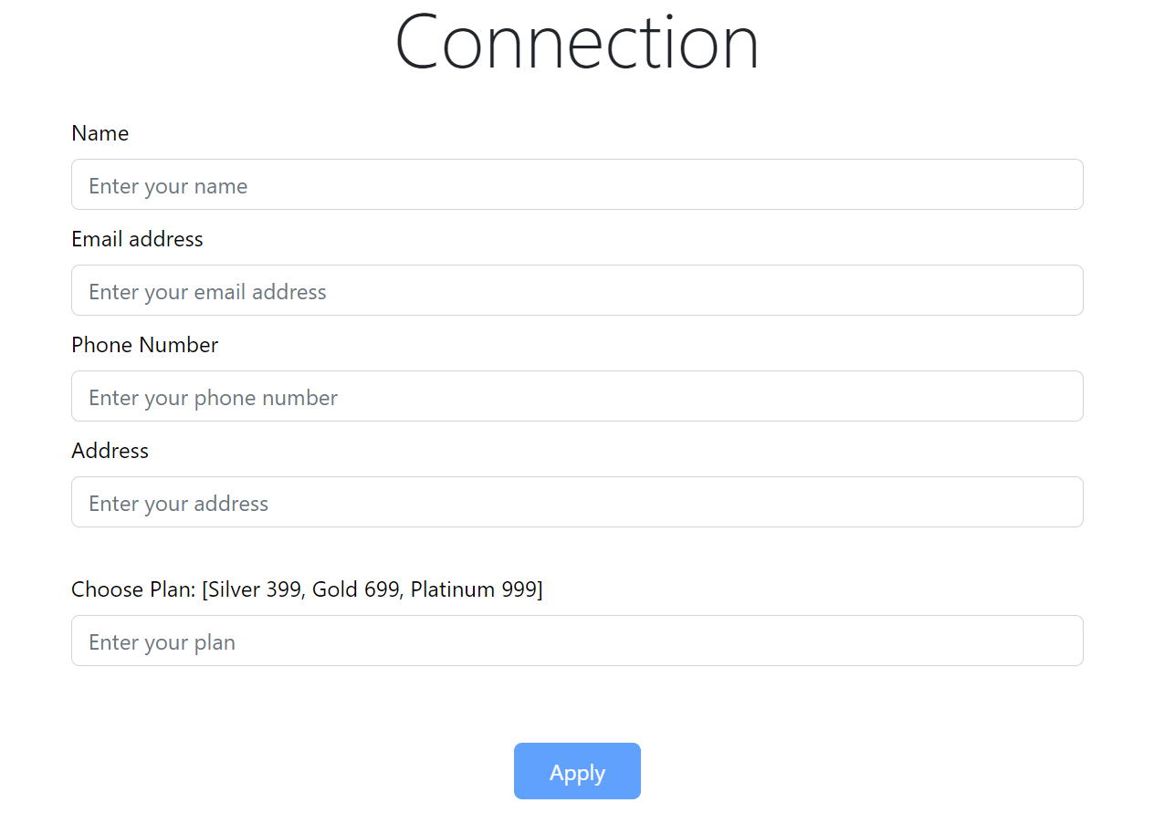

1. **Register Component**

Here new user/guest clicks on register link, it will open a register form. Here, user have to register themselves with the details given in the form.

I have also implemented validation in the form so that when user entered invalid data, we not let them signup. When user registered successfully, a pop up will show on the form that “registered successfully”, and will redirect them to home page.

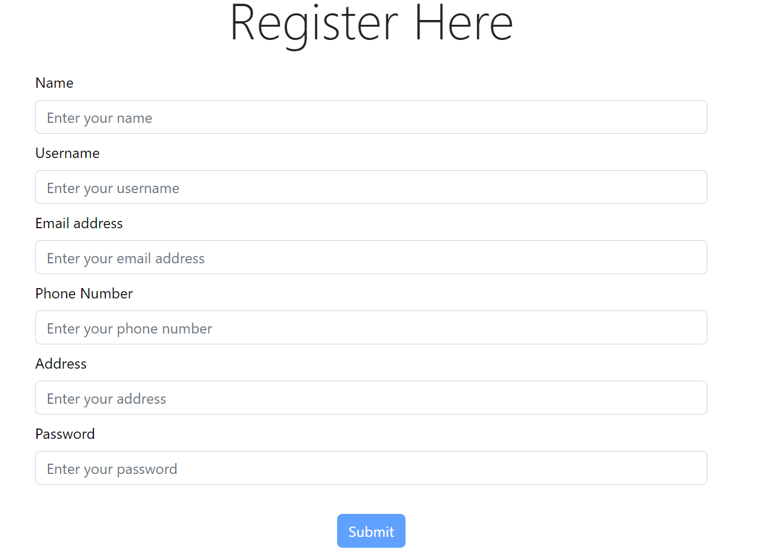

1. **Login Component**

When user clicks on login link, it will direct them to login form.

When user fills the form and click on login button, it will authenticate to get the data from the teleuser entity from backend and receives token and then save it to local storage.

If the credentials given wrong or doesn’t match from the backend, it will show error message to the user.

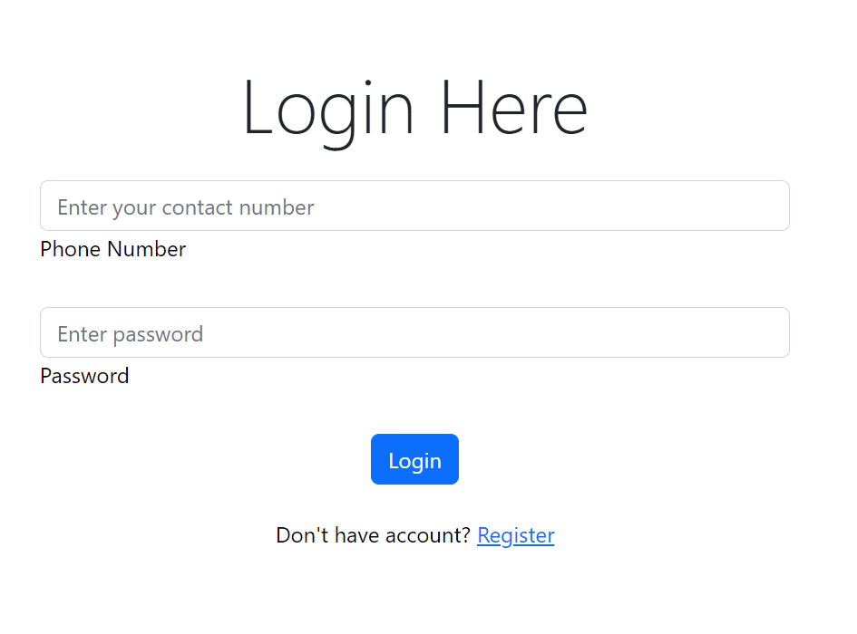

**f)Profile Component**

The profile will be displayed only to the user after successful login on the navbar/header. The user can see their details after clicking on the profile link.

The profile component fetches the data from backend by service.

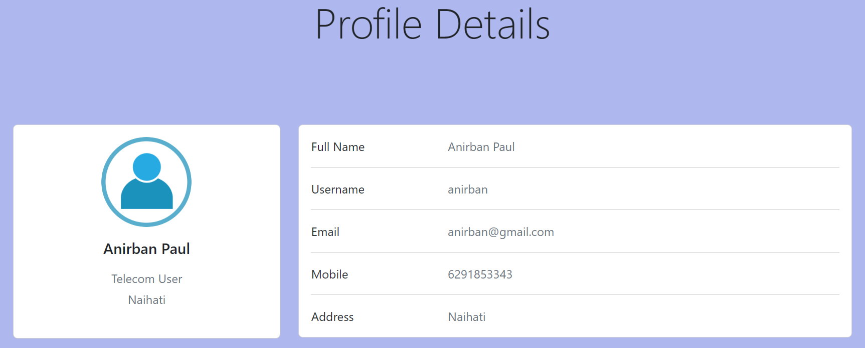

**g) Checkout Component**

After selecting the desired recharge plan, it will direct the user to the payment gateway or checkout page, where users have to fill valid card details, and the recharge amount and pay by the submit button. 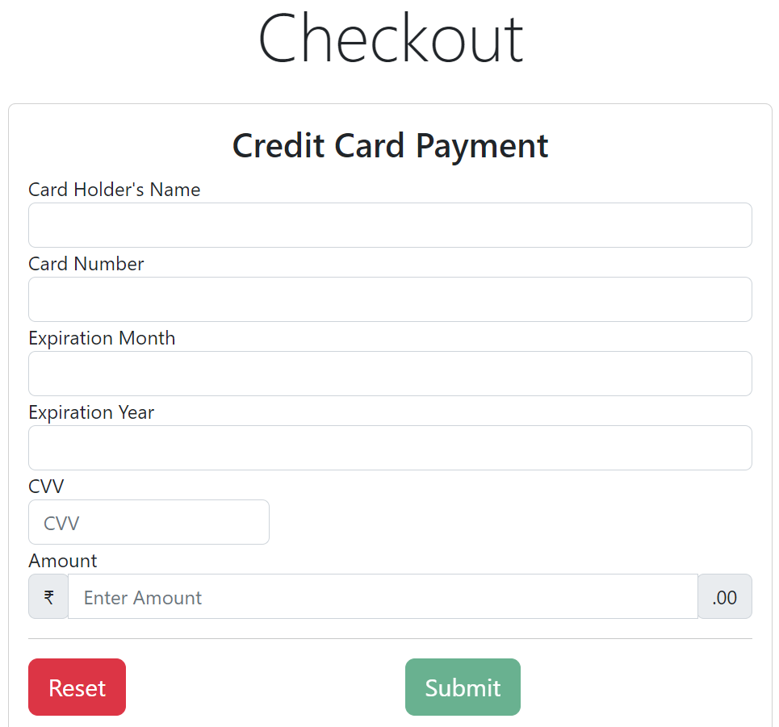

**h)Transaction Component**

When user clicks on payment/submit button in the checkout page, it will render the page where it will show recharge successful message to the user and will redirect the user to the home page with home button.

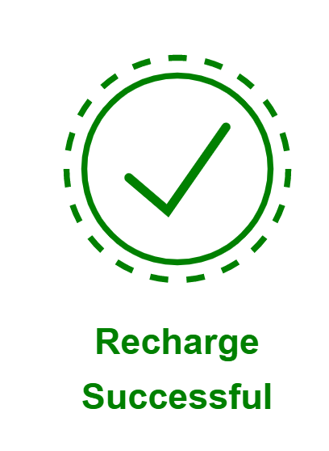

**CONCLUSION**

In the project, I have successfully built a Telecom Web Application using Spring Boot, MySQL, and Angular. Also, it has JWT authentication and session based login.